y **Ansible POC (Documentation)**

**Server (Controller) Setup on red hat Linux** [**https://www.youtube.com/watch?v=DZ84onseKek**](https://www.youtube.com/watch?v=DZ84onseKek)

1. Launch EC2 Instances From AWS Console.
2. Generate key and save private key using putty gen
3. Connect those instances using putty
4. Set Hostname for both servers

Hostname for Ansible controller(Linux): controller

**Vim /etc/hostname**



1. **vim /etc/sysconfig/network –**location to change hostname



Hostname change will be reflected after point 4 and 5 and rebooting the server



**Ansible Installation on server:-**

Adding RPM package to repo (**sudo -i**)

1. yum update

2.rpm –Uvh <https://dl.fedoraproject.org/pub/epel/epel-release-latest-7.noarch.rpm> ( if not working then type the command don’t copy paste)

3. yum install -y ansible

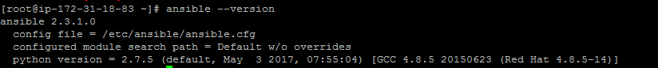

**Creating SSH Keys on server (controller)**

**sudo -i**

1.**ssh-keygen –t rsa ---**command to generate ssh keys

2. **cd /root/.ssh** ---- keys location server

3. **cat id_rsa.pub** and copy the content



**Configuring Ansible agent:**

**Setup hostname:**

1.Hostname for Ansible Agent(Amazon machine image Linux): Client

**vim /etc/sysconfig/network –**location to change hostname

**vim /etc/hostname**

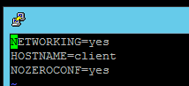



2.copy public key (**id_rsa.pub**) from controller and paste at **cd /root/.ssh/authorized_keys**

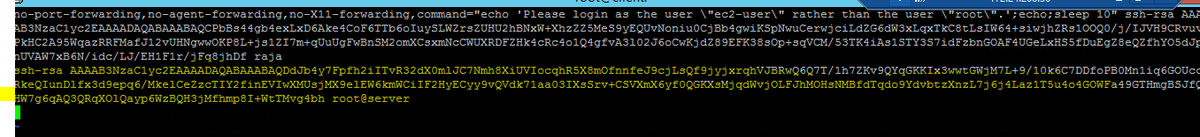

**3.**Now we have to enable PermitRootLogin in **vim /etc/ssh/sshd_config**

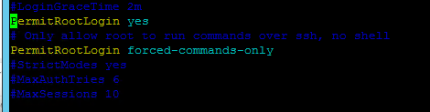

4.Restart the sshd service **/etc/init.d/sshd restart** or use **systemctl restart sshd.service**

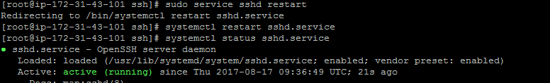

**5.**Add Hostname in **vi /etc/hosts**  file(Not required)

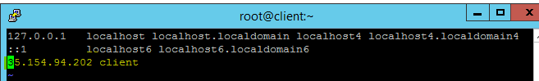

**Server side:**

**1.**Add client Hostname and public ip in **vim /etc/hosts**

**This is required to ssh client using its naming not ip**



Now we can check connection between server(controller) and client using below commands

1. **ssh client** (from server)

then enter **yes** now u are in client server

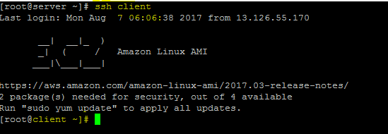

Now we are going to configure client to Ansible server

1. Add Client hostname at **vim /etc/Ansible/hosts** file



**2.**Check the Ansible connection is reachable to server and client using below command

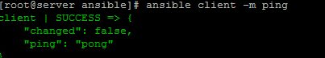

**----Windows Agent Configuration-------**

Ansible Windows client configuration:

1. Create windows. Yml file at \etc\ansible\group_vars(at Ansible controller)
2. Mention windows agent credentials (at Ansible controller)

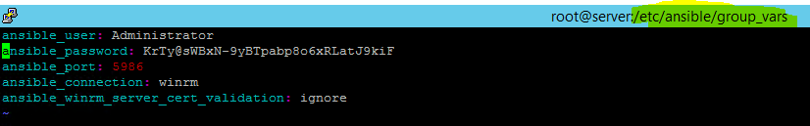

4.Mention windows agent ip address at Ansible host file(Ansible controller server)

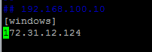

3.Now we have to enable the Winrm service (on windows agent)

For this we have to run the powershell script

Download <https://github.com/ansible/ansible/blob/devel/examples/scripts/ConfigureRemotingForAnsible.ps1>

And run the ConfigureRemotingForAnsible.ps1 on windows Agent

Now check with below command on Ansible controller

ansible **windows** -vvv -i **hosts** -m win_ping

**windows** - is the server type in **hosts** file

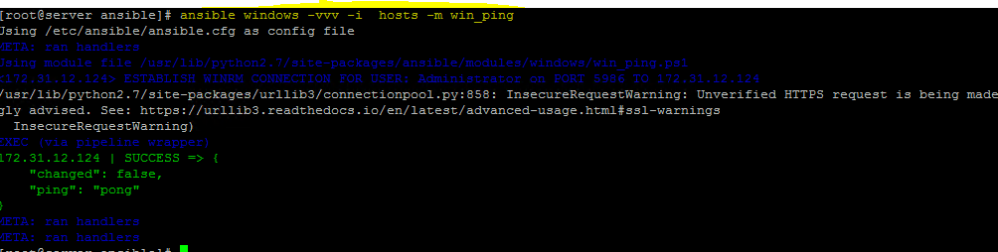

**If any error like below then install required packages**

Might be all three or any one of these

yum install python2-winrm python2-requests_ntlm python-requests

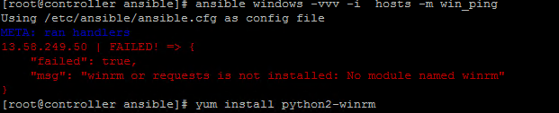

**[root@controller ansible]# ansible-playbook playbooks/win_install_iis.yml -e groupName="windows"**

**==========================================================================================================================================================================**

***More Details***

[**https://ansible-tips-and-tricks.readthedocs.io/en/latest/ansible/commands/**](https://ansible-tips-and-tricks.readthedocs.io/en/latest/ansible/commands/)

**Modules -**

**Filter gathered facts**

ansible client1 -m setup -a "filter=ansible_distribution*"

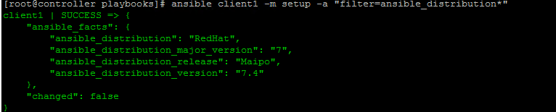

**Display all gathered facts**

ansible <HOST_GROUP> -m setup | less

**Check for bad syntax**

One can check to see if code contains any syntax errors by running the playbook.

Check for bad syntax:

ansible-playbook playbooks/PLAYBOOK_NAME.yml --syntax-check

**Running a playbook in dry-run mode**

Sometimes it can be useful to see what Ansible might do, but without actually changing anything.One can run in dry-run mode like this:

ansible-playbook playbooks/PLAYBOOK_NAME.yml --check



**Execute playbook- cd /etc/ansible**

